

The MyAccounts Program

public class MyAccounts
{
public static void main(String[] args)
{
Account rAcct = new Account(100.0);
printMe(rAcct);

SavingsAccount sAcct = new SavingsAccount(100.0, 0.5);
printMe(sAcct);

}

private static void printMe(Account a)
{
System.out.println(a);
}
}

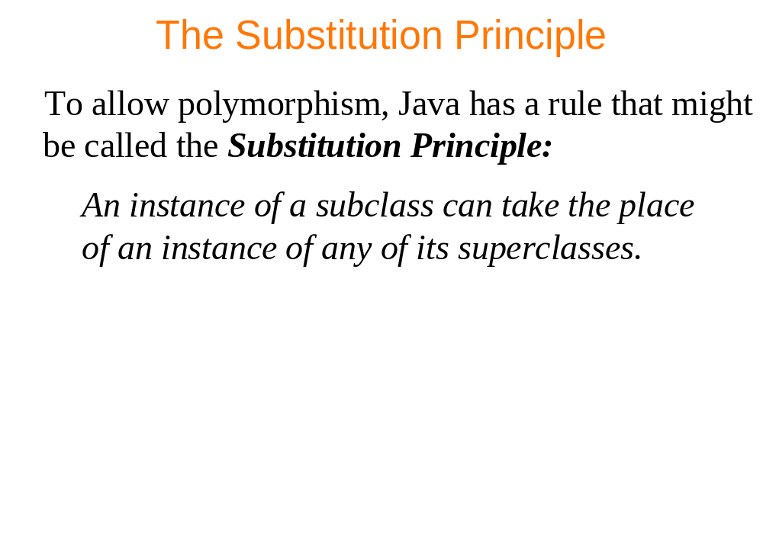


The Fruity Program

class Fruit
{
public void print() {
System.out.println("Fruit");
}
}

class Orange extends Fruit
{
public void print() {
System.out.println("Orange");
}
public void printTwo() {
super.print();
}
}

class Mandarin extends Orange
{
public void print() {
System.out.println("Mandarin");
}
}

public class Fruity
{
public static void main(String[] args)
{
try{
Fruit a = new Mandarin();
a.print();
a = new Orange();
a.print();

Fruit f = new Fruit();
Mandarin m = new Mandarin();
f = m;

if (f instanceof Orange)
{
Orange o = (Orange) f;
o.printTwo();
}
}
catch (ClassCastException e)
{
System.err.println(e.getMessage());
}
}
}

